Make-up Lab: Investigating an Unexpected Fluorescence in Chlorophyll.
Introduction:
In this one-week lab, you will be further investigating the fluorescence of chlorophyll. Chlorophyll absorbs light in the UV, violet, and blue regions of the EM spectrum and fluoresces in the red region. The intensity of the red color is a function both of how much chlorophyll is in the sample and of what light source is used to excite the chlorophyll. Chemical compounds that exhibit fluorescence are commonly called fluorophores (or fluorochromes). By measuring the intensity and nature of this fluorescence, plant ecophysiology can be investigated.
Your lab will consist of two parts:
- reproducing an 'unexpected' observed fluorescence of chlorophyll, and
- investigating the system to determine and explain the source of the fluorescence.
The lab report you turn in should discuss answers to questions posed in the sections below as well as any insights you gain from your explorations and investigations, along with the data supporting those insights.
What we did in Lab 10:
In Lab 10 we explored the in vitro fluorescence of a chlorophyll system (a sample of spinach chlorophyll suspended in ethanol) when exposed to a variety of light sources (green, blue and white LEDs).
While we expected that the blue LED would be capable of generating fluorescence in the chlorophyll, several lab groups noticed the chlorophyll system fluorescing when exposed to the green LED. Samples of these groups’ observations are shown on the next page. Carefully compare the light source spectra (first graph for each source) to the spectra for the light scattered and fluoresced by the chlorophyll system as sensed by the fiber optic (all other graphs). As you can see, the green LED is producing a distinct (and unexpected!) fluorescence from our chlorophyll system.

Blue light excitation spectrum:
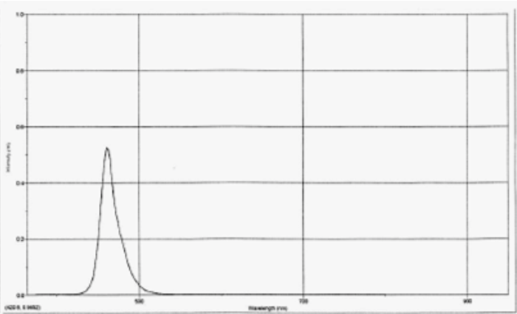
Blue light emission spectrum:
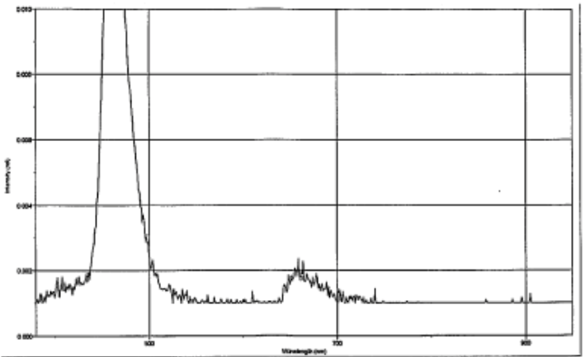

Green light excitation spectrum:

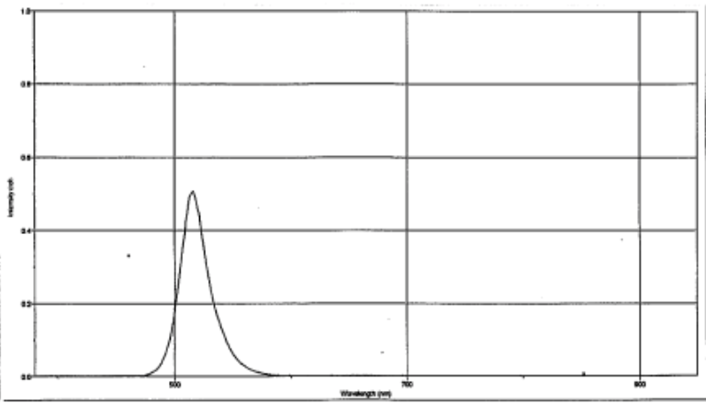

Green light emission spectrum:
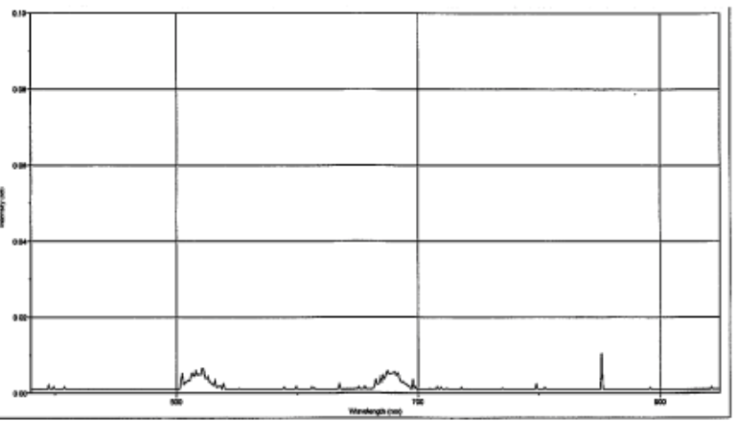

Why this was 'unexpected':
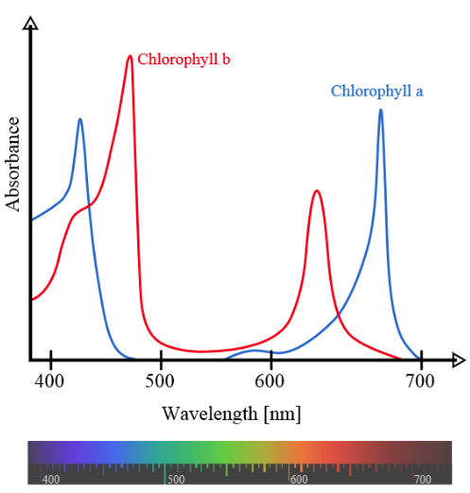
“Chlorophyll absorbs light most strongly in the blue portion of the electromagnetic spectrum, followed by the red portion. Conversely, it is a poor absorber of green and near-green portions of the spectrum, hence the green color of chlorophyll-containing tissues.” The types of chlorophyll most commonly found in plants are chlorophyll a and chlorophyll b. (It turns out that there are more than six different forms of chlorophyll!)
The absorbance spectra of free chlorophyll a (blue) and b (red) in a solvent are shown at left. The spectra of chlorophyll molecules are slightly modified in vivo depending on specific pigment-protein interactions. The measurement of the absorption of light is complicated in vitro by the solvent used to extract it from plant material, which affects the values obtained.
From this spectral information, which of the forms of chlorophyll could be responsible for absorption of green light leading to fluorescence?
Here is a little more information about fluorescence, chlorophyll a, and chlorophyll b.
“The capacity of a plant to carry out photochemistry is limited and will depend upon a range of factors including stresses caused by environmental conditions. Absorbed light energy in excess of that used for photochemistry must be effectively dissipated by non-photochemical processes. Such processes include the emission of heat and re-emission of small but diagnostically significant amounts of the absorbed radiation as longer wavelength red/far-red light energy. This re-emission of light is termed chlorophyll fluorescence. Although chlorophyll fluorescence emission from whole leaf systems is too weak to be viewed with the naked eye, it can be observed from illuminated extracts of a chlorophyll solution. Peak chlorophyll fluorescence occurs in the red region of the spectrum (685 nm) and extends into the infra-red region to around 800 nm. Each of these processes operate in direct competition for a finite pool of absorbed energy, any change in energy utilization by one process produces a complementary change in the others. This fact enables chlorophyll fluorescence to be used as a rapid and reliable non-invasive probe of photochemistry.”

“Chlorophyll is a chlorin pigment, which is structurally similar to and produced through the same metabolic pathway as other porphyrin pigments such as heme. At the center of the chlorin ring is a magnesium ion. This was discovered in 1906, and was the first time that magnesium had been detected in living tissue. For the structures depicted [below], some of the ligands attached to the Mg2+ center are omitted for clarity. The chlorin ring can have several different side chains, usually including a long phytol chain. There are a few different forms that occur naturally, but the most widely distributed form in terrestrial plants is chlorophyll a.”
“The trapping of light energy is the key to photosynthesis. The first event is the absorption of light by a photoreceptor molecule. The principal photoreceptor in the chloroplasts of most green plants is chlorophyll a, a substituted tetrapyrrole. The four nitrogen atoms of the pyrroles are coordinated to a magnesium ion. Unlike a porphyrin such as heme, chlorophyll has a reduced pyrrole ring. Another distinctive feature of chlorophyll is the presence of phytol, a highly hydrophobic 20-carbon alcohol, esterified to an acid side chain. Chlorophylls are very effective photoreceptors because they contain networks of alternating single and double bonds. Such compounds are called polyenes. They have very strong absorption bands in the visible region of the spectrum, where the solar output reaching Earth also is maximal. The peak molar absorption coefficient of chlorophyll a is higher than 10⁵ M^{–1} cm^{–1}, among the highest observed for organic compounds.”
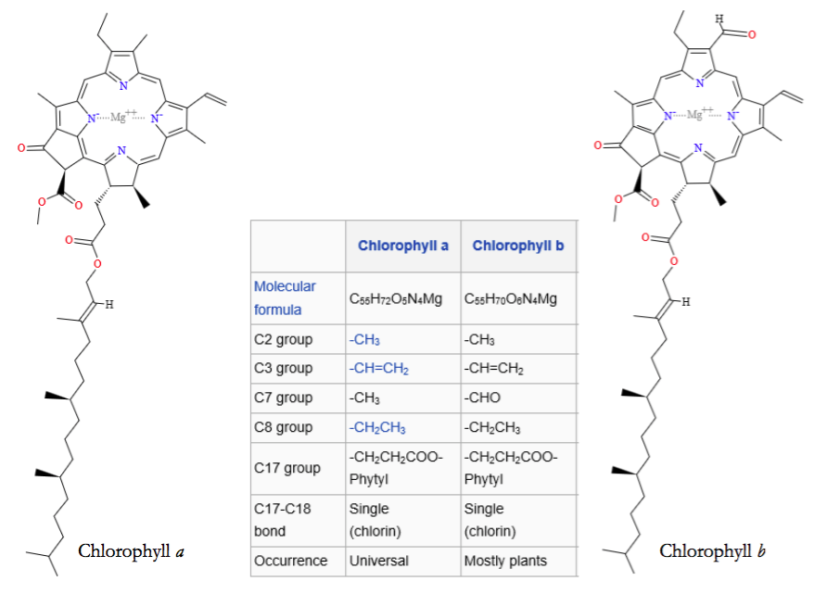

Materials and Methods

Part I: Reproducing the Observed 'Unexpected' Fluorescence of Chlorophyll

Using the chlorophyll solution from Lab 10, reproduce the observed 'unexpected' fluorescence when exposed to the green LED light source. It may be easiest to accomplish this if the room is dark and/or the sample, source, and detector are shielded from ambient light (try over- turning a lightweight cardboard box to cover the set-up). You may also find it necessary to mess with some of the spectrometer parameters. Consider the following questions:
- Are you able to detect red fluorescence due to the exposure to the green LED?
- How does the emitted light (fluorescence) compare to the absorbed light (light source)?
- Is this a high intensity fluorescence or a low intensity fluorescence? How can you tell?
- What factors affect the intensity of the observed fluorescence?

Part II: Investigating the System to Determine and Explain the 'Unexpected' Fluorescence

Now that you also have observed this 'unexpected' fluorescence, it is your task to figure out what is going on here. Consider the following questions:
- Could something else in the system be responsible for the observed fluorescence? If so, what?
- If nothing else in the system is responsible, is the chlorophyll truly fluorescing due to the green light? What other options are there?

Taken from: http://en.wikipedia.org/wiki/Chlorophyll
Taken from: http://hansatech-instruments.com/products/introduction-to-chlorophyll-fluorescence/
Taken from: http://en.wikipedia.org/wiki/Chlorophyll
Berg JM, Tymoczko JL, Stryer L. Biochemistry. 5th edition. New York: W H Freeman; 2002. Section 19.2, Light Absorption by Chlorophyll Induces Electron Transfer.

